1

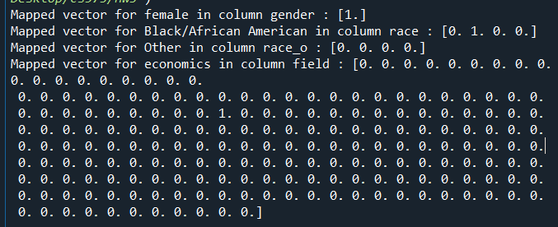

2





3

(iii)

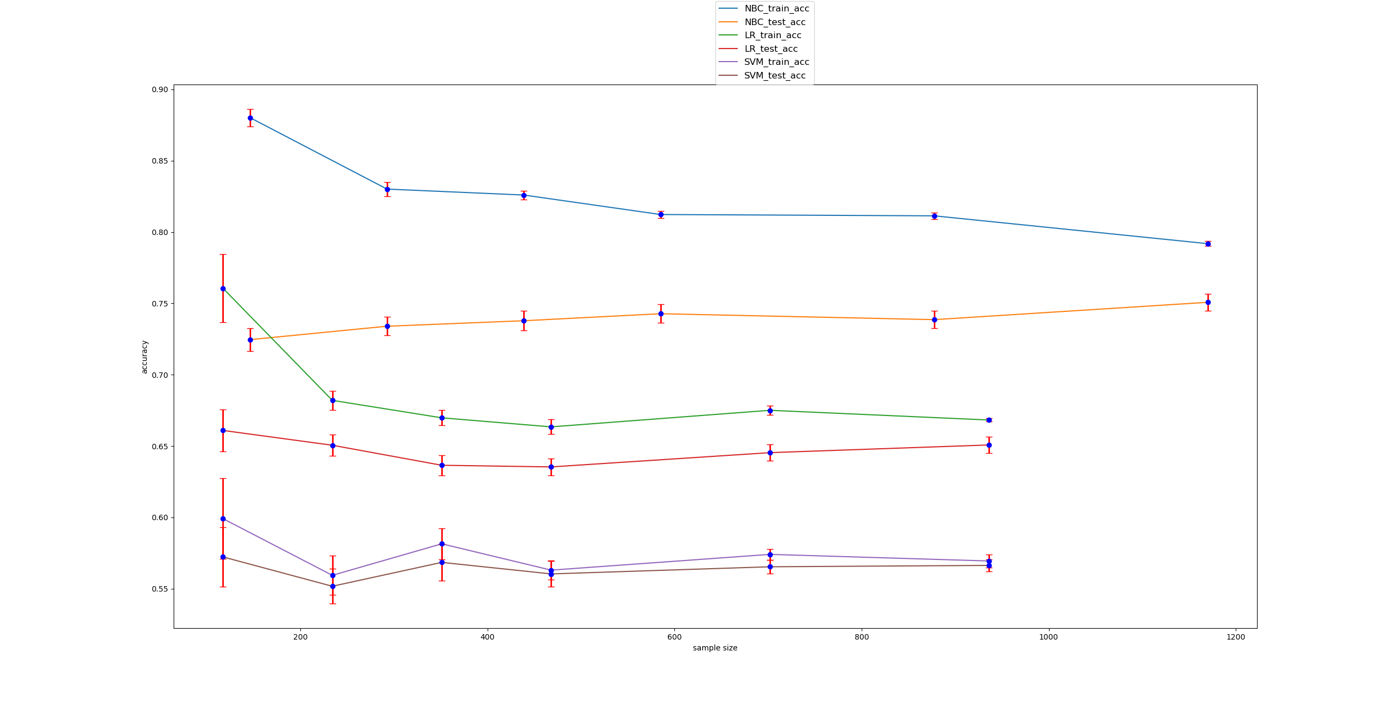

(iv) hypothesis: the performance of LR and SVM are different

(v)

The pair-wise t-test between the training accuracies of LR and SVM, and the pair-wise t-test between the test accuracies of LR and SVM are as follows



Both p values <0.05, means that they are statistically different.